User Story (Blog Management)
As a user of the travel recommendation system,
I want to create, edit, delete, and manage my travel blog posts,
so that I can share my travel experiences and keep my content up to date
I also want to read, comment on, and reply on the posts,
so that I can engage with the travel community and provide feedback on content.

Description
This user story focuses on providing users with the ability to manage their travel blog posts. Users can create new blog entries, edit existing ones, delete those they no longer want to share. The system should support image uploads.
Users can read and browse through blog content, leave comments, reply to others, like posts

Acceptance Criteria
- Blog Creation:
  - Users can create a new blog post with a title, body content.
  - Users can upload image to accompany the post.
- Blog Editing:
  - Users can edit the content, title of the created blog.
- Blog Deletion:
  - Users can delete their own blog posts.
  - A confirmation dialog is shown before deleting a post.

User Story (Blog Interaction)
I also want to read, comment on, and reply on the posts,
so that I can engage with the travel community and provide feedback on content.

Description
Users can read and browse through blog content, leave comments, reply to others, like posts

Acceptance Criteria
- Blog Browsing:
- Users can browse blog posts that have been recently posted.
- Commenting and Replying
- Users can comment on blog posts.
- Users can reply to comments made by others.
- Users can edit or delete their comments.
- Users can reply to comments made by other users

Dependencies Identified
- Authentication System
- User System
- Appropriate Database Creation

Flow Diagram

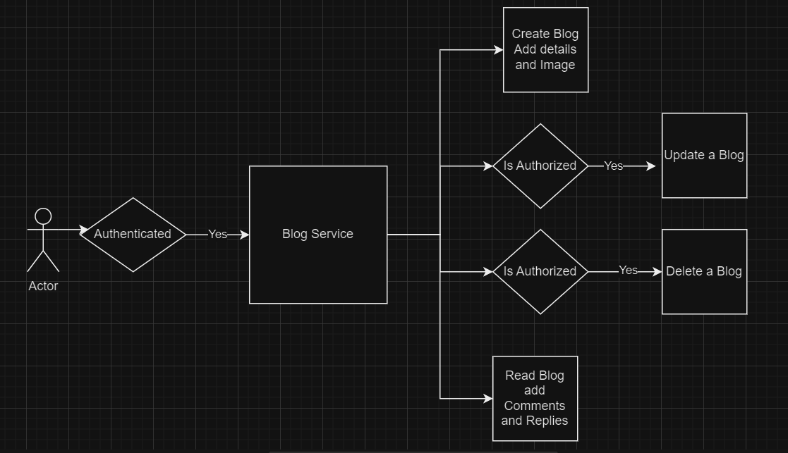

UI Mock-ups
